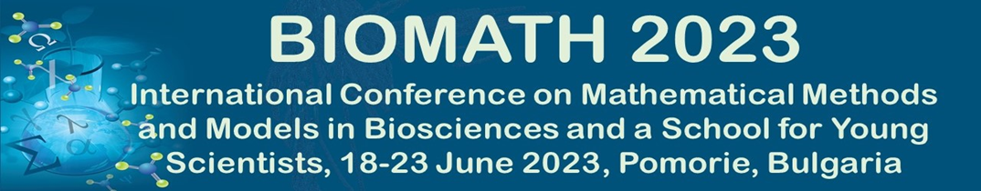

APPLICATION FOR SMB FINANCIAL SUPPORT

Tis call is open to Graduate Students, Postdoctoral Associates, and Junior Faculty from developing or low income countries.
Please complete the this form to apply for SMB grant for partial support of your participation in BIOMATH 2023. Make sure that you first register and submit your Abstract following the instructions at the BIOMATH 2023 website: http://www.biomath.bg/2023/participation.php. Junior faculty and postdoctoral associates should submit this application form along with curriculum vitae. Graduate students should submit this application form along with curriculum vitae and a letter of recommendation from a supervisor. E-mail the application documents as attachments in a single e-mail to roumen.anguelov@up.ac.za. Please put “FINANCIAL AID REQUEST: BIOMATH 2023” in the subject line of your e-mail. Incomplete requests may be rejected.

Name:

Affiliation:

E-mail address:

Number of Years in the Graduate Program or Date PhD Granted:

Title of Talk or Poster Presentation:

