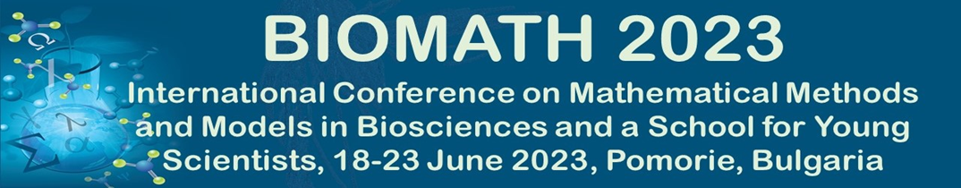

**APPLICATION FOR FINANCIAL SUPPORT**

**This support is provided by the Bulgarian Fund for Scientific Research. The call is open to doctoral students, postdoctoral fellows and junior faculty (untenured, not more than 5 years since PhD) from Bulgarian scientific organizations or universities who participate in the conference with talk or poster presentation. The support covers the accommodation during the conference.**

Please complete this form to apply for FSR grant for partial support of your participation in BIOMATH 2023. Make sure that you first register and submit your Abstract following the instructions at the BIOMATH 2023 website: [**http://www.biomath.bg/2023/participation.php**](http://www.biomath.bg/2023/participation.php). Junior faculty and postdoctoral fellows should submit this application form along with curriculum vitae. Doctoral students should submit this application form along with curriculum vitae and a letter of recommendation from a supervisor. E-mail the application documents as attachments in a single e-mail to[**roumen.anguelov@up.ac.za**](mailto:roumen.anguelov@up.ac.za). Please put “FSR FINANCIAL SUPPORT: BIOMATH 2023” in the subject line of your e-mail.

**Name:**

**Affiliation:**

**E-mail address:**

**Number of Years in the Graduate Program or Date PhD Granted:**

**Title of Talk or Poster Presentation:**