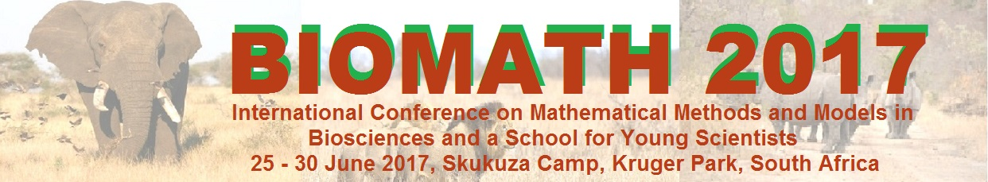

APPLICATION FOR FINANCIAL AID

Graduate Students, Postdoctoral Associates, and Junior Faculty: Please complete the following form to apply for financial aid. Make sure that you first submit your Title and Abstract following the instructions at the BIOMATH 2017 website: http://www.biomath.bg/2017/participation.php. Junior faculty and postdoctoral associates should submit this application form along with curriculum vitae. Graduate students should submit this application form along with curriculum vitae and a letter of recommendation from a supervisor. E-mail the application documents as attachments in a single e-mail to roumen.anguelov@up.ac.za. Please put “FINANCIAL AID REQUEST: BIOMATH 2017” in the subject line of your e-mail. Incomplete requests may be rejected.

Name:

Affiliation:

E-mail address:

Number of Years in the Graduate Program or Date PhD Granted:

Support requested for:
Mark with X
Transfer from Johannesburg Airport to conference venue and back
(your flight should land at Johannesburg airport before 10:00 on 25 June 2017)
Support for accommodation (not exceeding 50% of shared accommodation)
Note: Free dormitory style accommodation is available for booking with registration. There is no need to apply for it here.
Reduced or waived registration fee

Title of Talk or Poster Presentation:

